SMART MULTI-TIERED PARKING MANAGEMENT SYSTEM
USING INTERNET OF THINGS FOR SKY SCRAPPERS

Dr. P. A. Harsha Vardhini
Department of Electronics & Communication Engineering
Vignan Institute of Technology & Science

T. Nanda Kumar
Department of Electronics & Communication Engineering
Vignan Institute of Technology & Science
D. Venkat Ramana Reddy
Department of Electronics & Communication Engineering
Vignan Institute of Technology & Science
N. Karthik
Department of Electronics & Communication Engineering
Vignan Institute of Technology & Science

P. Raghavendra Reddy
Department of Electronics & Communication Engineering
Vignan Institute of Technology &
Science

Abstract— This project demonstrates the design and implementation of a smart parking management system using an Arduino microcontroller, IR sensors, a servo motor, and an LCD display. The system efficiently manages and monitors parking spaces across two floors of a parking lot. It utilizes a set of IR sensors to detect the availability of parking spots, with the ability to identify vacant spaces both on the ground and first floors. An entrance IR sensor triggers the opening of the parking gate when a vehicle approaches, provided that there is at least one available parking space. If no space is available, the system alerts the user with a message on the LCD display. The parking spaces are monitored by a series of 8 IR sensors, connected in pairs across two levels. The available parking spots are displayed on the LCD screen, showing whether a spot is free and indicating its location (Ground or First Floor). The servo motor is used to control the entrance gate, which opens when a parking space is available and automatically closes after a short delay. The system offers real-time updates of parking availability, ensuring a smooth and efficient parking process.
Keywords—— Arduino microcontroller, IR sensors, Servo motor, LCD display, Parking space detection, Two-floor parking management Real-time monitoring

Introduction
As the number of vehicles on the road increases, parking spaces become more limited, leading to intense competition for available spots. This scarcity results in drivers wasting valuable time searching for parking, which in turn causes delays, frustration, and inefficiency. In crowded urban areas, parking garages and lots often operate at full capacity, leaving no space for incoming vehicles.

Traffic Congestion
Drivers searching for parking contribute significantly to urban traffic congestion. Studies have shown that a large proportion of city traffic is made up of drivers circulating in search of an empty parking space. This not only leads to inefficiencies in the transportation system but also contributes to higher levels of pollution, as vehicles emit greenhouse gases while idling or driving in circles.

Manual Monitoring of Parking Availability
Traditional parking management systems rely on manual monitoring by attendants or static signage to indicate parking availability. This method is prone to errors and inefficiencies, as it does not provide real-time information about the actual status of the parking spaces. As a result, drivers may receive incorrect information, leading to wasted time and frustration.
The objective of the Smart Parking System project is to design and implement an automated solution to efficiently manage parking spaces in a parking lot. The system leverages technologies such as infrared (IR) sensors, a servo motor for gate control, and an LCD display to provide real-time updates. This system aims to reduce traffic congestion, improve parking space utilization, and create a seamless and convenient parking experience for users.
Primary Goals:
- Automated Parking Space Detection: The system automatically detects available parking spaces using IR sensors placed across the parking lot. Each sensor determines whether a parking space is occupied or free, ensuring accurate real-time data about the availability of spaces.
- Gate Control Automation: The parking gate is controlled by a servo motor. When a vehicle is detected and there is an available parking space, the system opens the gate to allow entry. Once the vehicle enters the lot, the gate automatically closes after a short delay.
- Real-Time Updates on LCD Display: The system continuously monitors the parking lot and displays available parking spaces on a 16x2 LCD screen. The display updates in real-time to reflect changes in the parking lot’s occupancy, helping users easily find available spots. If no spaces are available, the display will indicate "No Space Available," guiding users effectively.
- User-Friendly Interface: The system is designed to be intuitive and easy to use. The interface provides clear information about the status of the parking lot, ensuring that users can easily interpret the available parking spaces. Additionally, minimal interaction is required from the user, as the system automatically detects the presence of vehicles and manages gate operations.

LITERATURE REVIEW
[1] Dalal, Y. M., Kumar Raja, D. R., & Ashwin Kumar, U. (2023). Eco Park: A low-cost and sustainable approach for smart parking systems. In 2023 World Conference on Communication & Computing (WCONF). IEEE.This paper presents Eco Park, a smart parking system designed to be both cost-effective and environmentally sustainable. The system leverages IoT technologies to optimize parking space utilization and reduce traffic congestion. It incorporates renewable energy sources and smart sensors to enhance user experience. The study evaluates the system's performance in real-world scenarios, demonstrating significant improvements in parking efficiency. The findings suggest that Eco Park can serve as a model for future smart city initiatives.[2]GokulKrishna, S., Harsheetha, J., Akshaya, S., & Jeyabharathi, D. (2021). An IoT based smart outdoor parking system. In 2021 7th International Conference on Advanced Computing and Communication Systems (ICACCS).IEEEThis research introduces an IoT-based smart outdoor parking system aimed at addressing urban parking challenges. The system utilizes sensors and mobile applications to provide real-time parking availability information to users. It enhances user convenience by allowing for remote reservation and payment options. The paper discusses the architecture, implementation, and testing of the system in a university campus setting. Results indicate a reduction in search time for parking spaces and improved user satisfaction.
[3] Askarbek, K., & Bahrami, M. R. (2023). Smart parking systems: A review on user interface features and real-world examples. In 2023 International Ural Conference on Electrical Power Engineering (UralCon). IEEE.
This review paper analyzes various smart parking systems, focusing on user interface features and their impact on user experience. It categorizes existing systems based on functionality, accessibility, and user engagement. The authors present real-world examples to illustrate the effectiveness of different interface designs. The study highlights the importance of intuitive interfaces in promoting user adoption of smart parking technologies. Recommendations for future developments in user interface design are also provided. [4] Hainalkar, G. N., & Vanjale, M. S. (2017). Smart parking system with pre & post reservation, billing and traffic app. In 2017 International Conference on Intelligent Computing and Control Systems (ICICCS). IEEE.This paper discusses a comprehensive smart parking system that integrates pre- and post-reservation capabilities along with billing and traffic management features. The system aims to streamline the parking process, reducing wait times and enhancing user convenience. It employs a mobile application that allows users to reserve parking spots in advance and manage payments seamlessly. The authors present a case study demonstrating the system's effectiveness in a busy urban environment. The results indicate a significant decrease in traffic congestion and improved user satisfaction.[5] Campo, G., Cipria, F., Russo, M., Santoro, C., & Santoro, F. F. (2024). ChirpPark: A smart and sustainable parking system protocol for smart cities and multi-agent vehicles. In 2024 IEEE Smart Cities Futures Summit (SCFC). IEEE.
ChirpPark introduces a novel protocol for smart parking systems that supports multi-agent vehicles in urban environments. The protocol facilitates communication between vehicles and parking infrastructure, optimizing space utilization and reducing emissions. The paper outlines the technical framework and algorithms used to implement the system. A simulation study demonstrates the protocol's effectiveness in managing parking resources efficiently. The findings suggest that ChirpPark can significantly contribute to the development of sustainable smart cities.[6] Arunkumar, S., Vanitha Sheba, M., Usha Naidu, S., Balaji Vijayan, V., Arun, S., & Thiagarajan, R. (2024). Seamless Wi-Fi integration enhancing the experimental model of smart car parking systems with IoT and modulated sensors. In 2024 2nd International Conference on Sustainable Computing and Smart Systems (ICSCSS). IEEE. This research explores the integration of seamless Wi-Fi connectivity in smart car parking systems enhanced by IoT and modulated sensors. The study presents an experimental model that demonstrates improved communication between vehicles and parking infrastructure. The authors discuss the benefits of real-time data transmission for parking management and user experience. Results from the experimental setup indicate enhanced system responsiveness and user engagement. The paper concludes with recommendations for future research in smart parking technologies. [7] Jenila, C., & Harshan, K. (2024). IoT-based smart parking system: Hardware-centric approach for addressing urban parking challenges. In 2024 2nd International Conference on Networking, Embedded and Wireless Systems (ICNEWS).IEEE.This paper presents a hardware-centric approach to developing an IoT-based smart parking system aimed at urban parking challenges. The system incorporates various sensors and devices to monitor parking space availability in real-time. The authors discuss the design, implementation, and testing phases of the system, highlighting its scalability and adaptability. A case study demonstrates the system's effectiveness in reducing parking search times and improving overall traffic flow. The findings emphasize the potential of hardware innovations in smart city applications.

PROPOSED METHODOLOGY
The Smart Parking System is designed to streamline the parking process by automating the detection of available parking spaces, controlling access gates, and providing real-time updates to users via an LCD display. The system employs various hardware components integrated with a software framework to ensure efficient operation in a parking lot environment. Below is a high-level overview of the system architecture and the primary components involved in its design

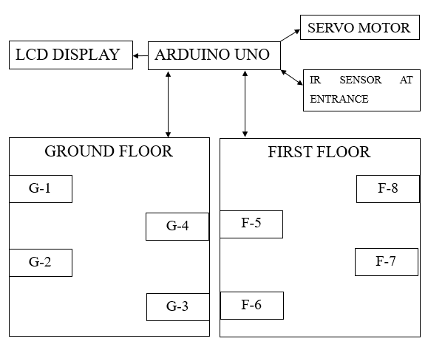
Fig 1: Implementation diagram

The architecture of the smart parking system can be divided into two main subsystems: Hardware Components and Software Components. These subsystems communicate with each other to provide a seamless experience for both users and administrators. The system architecture follows a modular design, where each component plays a specific role in ensuring optimal performance.
- Hardware Components: This includes the physical devices such as sensors, actuators, and controllers that interact with the environment and execute tasks like detecting available parking spaces, controlling the gate, and providing user feedback via the display.
- Software Components: The software is responsible for controlling the hardware components, processing sensor data, and providing real-time updates through the LCD display. The software is built using Arduino programming language, leveraging libraries to handle sensor inputs, motor controls, and display functions.
The system is designed for simplicity, scalability, and ease of use. It is capable of detecting available parking spaces, triggering the opening and closing of the gate using a servo motor, and updating the user with parking availability information on an LCD.

WORKING: When a vehicle approaches the entrance of the parking facility, a detection system is triggered. This system uses sensors (such as ultrasonic, infrared, or camera-based technology) to identify the presence of a vehicle. Once detected, the system initiates a process to search for an available parking slot within the facility. To facilitate smooth entry, the system operates a motorized gate. Upon successful detection of a vehicle, the gate automatically opens for a duration of 5 seconds, providing sufficient time for the vehicle to pass through. After the allotted time, the gate closes automatically to maintain security and control access. This precise timing ensures efficiency and minimizes the risk of unauthorized entry. After the vehicle has successfully entered the premises and the gate has closed, the system displays a friendly welcome message on an LCD or digital screen. This personalized interaction enhances the user experience and provides assurance that the vehicle is being guided to an available parking slot. The welcome message can also include additional details, such as parking guidelines or the allocated slot number. The allocation of slots will be done in a serial manner such that, the slots that are available in the ground floor are allocated initially. When all the slots in the first floor are occupied the vehicles are directed to the next floor. The process is repeated until the last slot in the parking area are occupied

IMPLEMENTATION & RESULT
WIRING DIAGRAM:

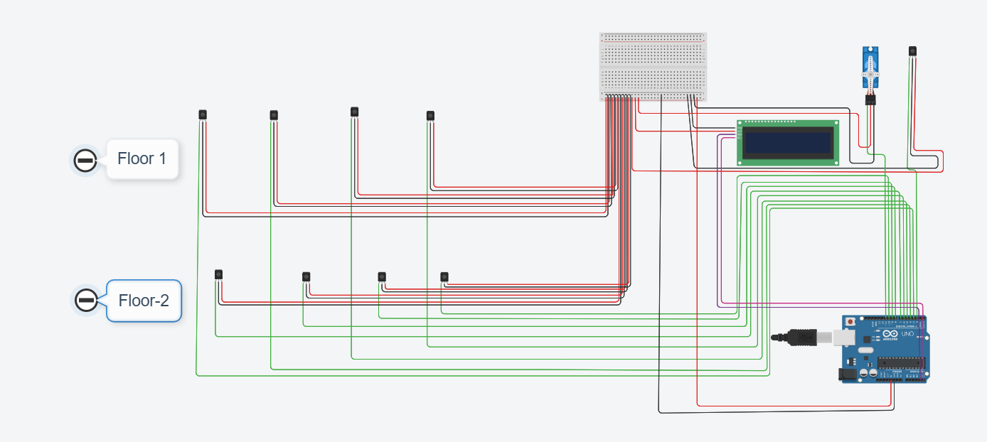
Fig 2: Wiring Diagram
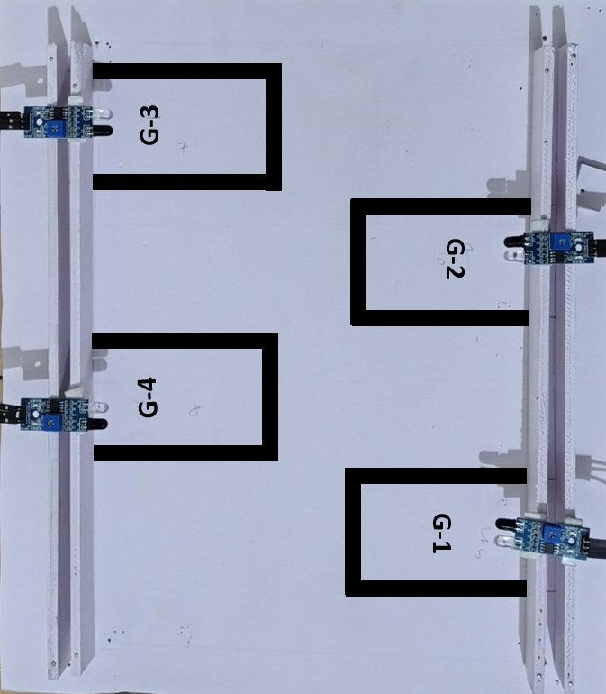
Fig 3: Layout of ground floor parking region

Fig.3 shows the layout of ground floor parking region. Where there will be 4 slots are mapped and named as “G-1,G-2, G-3 and G4”

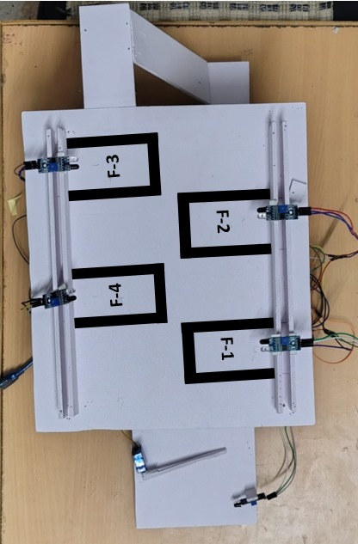
Fig 4: Layout of First floor parking region
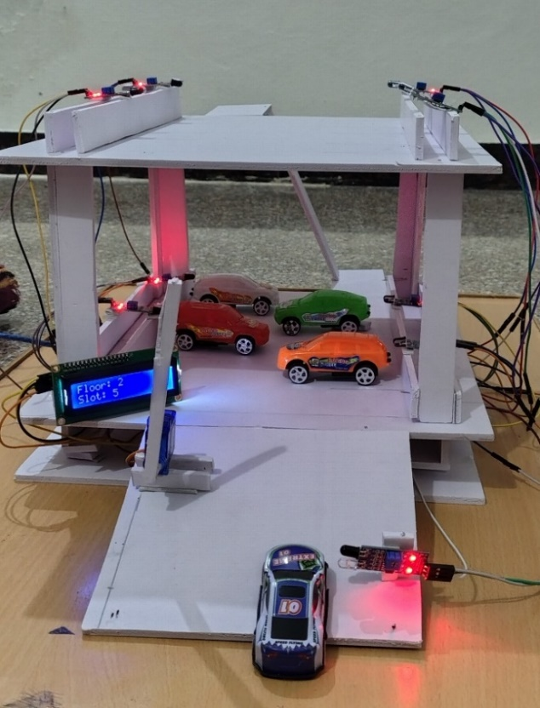

Fig.4 shows the layout of first floor parking region. There are another four parking slots allocated with their boundaries and they are named as “F-1, F-2, F-3 and F-4”.
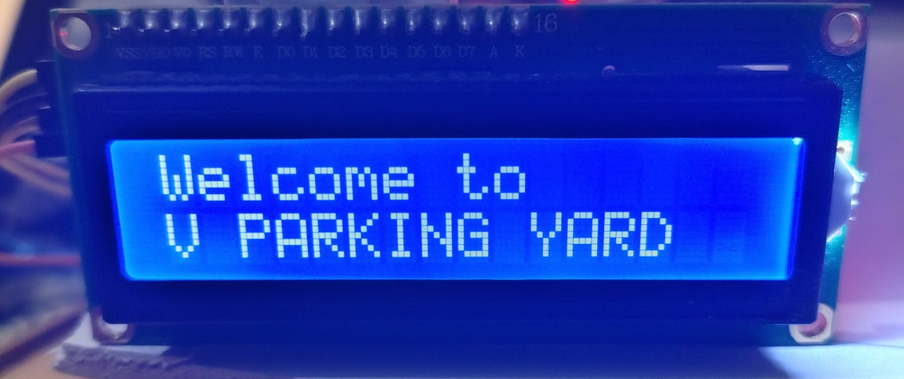 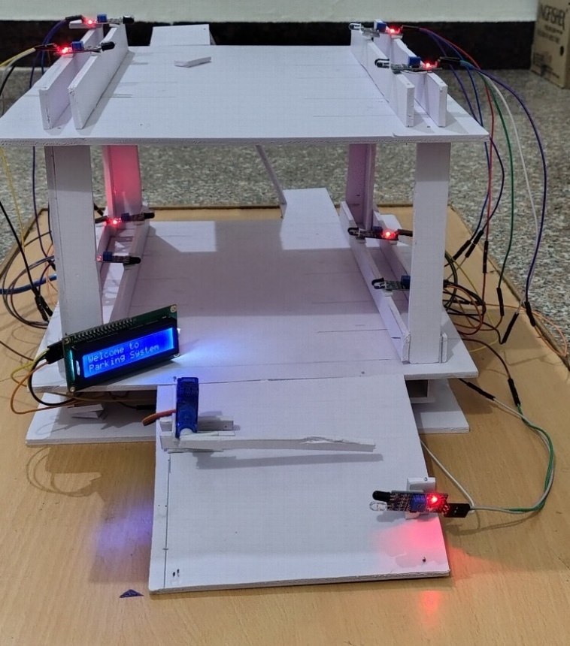 Fig 5: The empty parking area when no slot is occupied

In the scenario depicted by Figure 5, the parking area is entirely empty, with no slots currently occupied. When a vehicle enters the parking facility, the detection system activates and begins checking for available parking slots. Each parking slot is equipped with a sensor that continuously monitors its status. If a sensor reads HIGH, it indicates that the slot is available, and the system stores the corresponding slot ID in a variable called available Slot. The system iterates through all the sensors, checking their readings to identify which slots are free. Once an available slot is found, the vehicle is directed to that slot for parking, ensuring efficient space utilization.

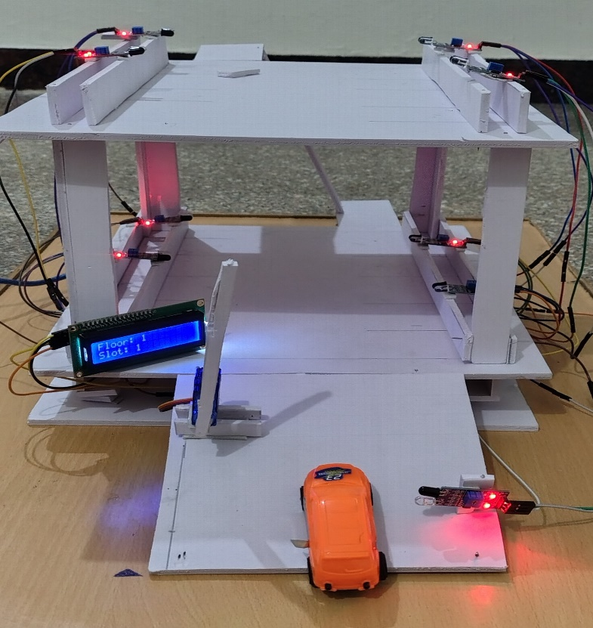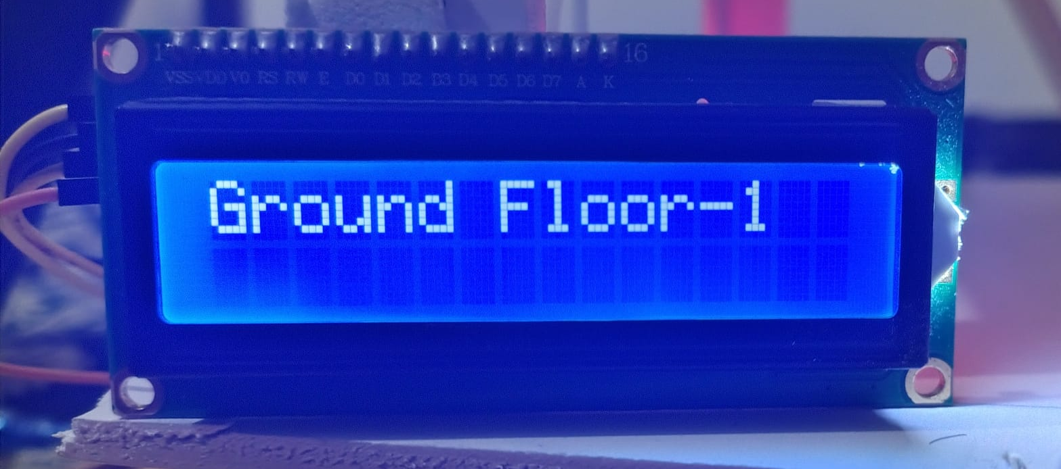
Fig 6: Allocation of the first slot in empty parking area

In Fig 6 When a vehicle enters the parking facility, the detection system activates and begins scanning for available parking slots on the ground floor. The system specifically checks the sensors on the ground floor first to prioritize accessibility for incoming vehicles. Once an available slot is found on the ground floor. The system opens the gate and allows the vehicle to park in the first slot in the ground floor.

Fig.7 illustrates a situation where no slots are available on the ground floor. In this case, the system checks for availability on the first floor. If a sensor reads HIGH, it indicates that the slot is available. Once an available slot is found on the first floor, the vehicle is guided to that slot for parking, facilitating an efficient and organized parking process. If a slot is found on the first floor, the same procedure is followed: the gate opens, and the system displays the floor and slot number to guide the driver to the vacant space. This multi-floor allocation ensures maximum utilization of parking resources.
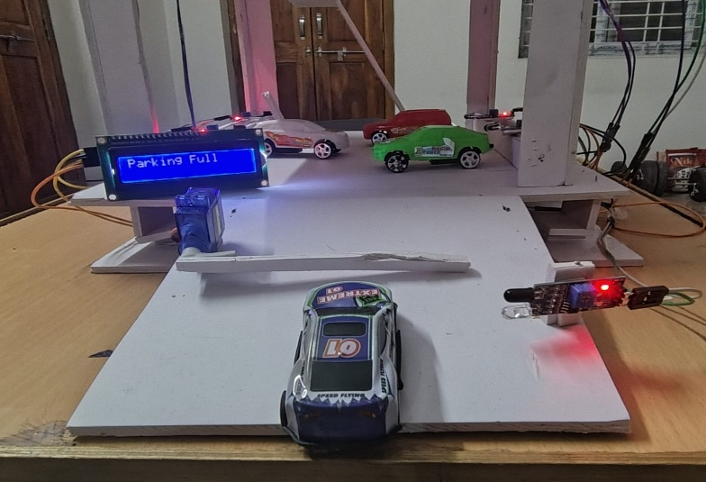

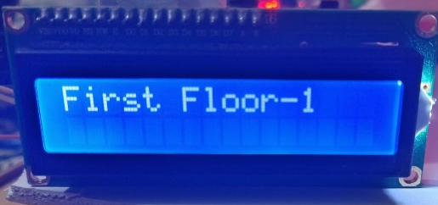
Fig 7: Ground floor is occupied and directing the vehicles to the upper level
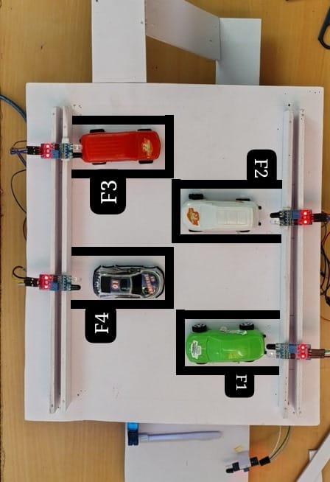
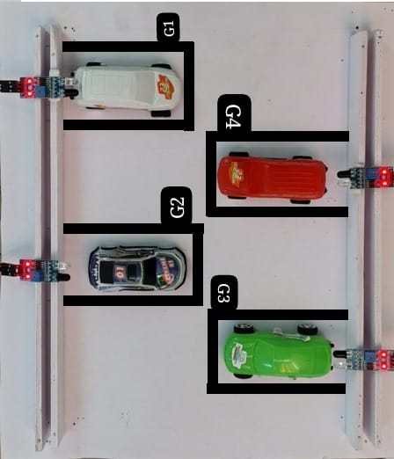
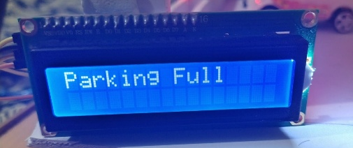

Fig 7 : Parking full

CONCLUSION

The Automated Parking System project has successfully demonstrated the potential of intelligent systems in addressing urban parking challenges. This system, integrating hardware and software components such as IR sensors, Arduino microcontrollers, stepper motors, and LCD displays, provides an efficient, automated solution to parking management. The primary goal of optimizing parking space allocation and automating the entrance/exit gate based on real-time availability has been achieved.
- Automated Parking Detection: The system accurately detects available parking spaces in real-time using IR sensors, improving the efficiency of space usage and reducing the time spent searching for a spot.
- Gate Control Mechanism: The servo motor successfully opens and closes the parking entrance gate based on the presence of vehicles, making the entry process seamless for drivers.
- Real-Time Feedback: The LCD display provides users with clear and immediate information on the availability of parking spaces, ensuring a smooth user experience.
- System Integration: The communication between hardware components, including the sensors, motor, and display, was smooth, resulting in a reliable and responsive system. The code executed on the Arduino microcontroller handled the logic of space checking, gate control, and user display without significant delays or errors.
This work successfully highlights how automation can enhance urban infrastructure. It reduces human intervention, streamlines parking operations, and improves the overall efficiency of parking systems. Furthermore, the system has demonstrated its potential for scalability, as it can be expanded to larger parking areas or integrated into multi-floor parking facilities with more sensors.

References
- Dalal, Y. M., Kumar Raja, D. R., & Ashwin Kumar, U. (2023). Eco Park: A low-cost and sustainable approach for smart parking systems. In 2023 World Conference on Communication & Computing (WCONF). IEEE.
- GokulKrishna, S., Harsheetha, J., Akshaya, S., & Jeyabharathi, D. (2021). An IoT based smart outdoor parking system. In 2021 7th International Conference on Advanced Computing and Communication Systems (ICACCS). IEEE.
- Askarbek, K., & Bahrami, M. R. (2023). Smart parking systems: A review on user interface features and real-world examples. In 2023 International Ural Conference on Electrical Power Engineering (UralCon). IEEE.
- Hainalkar, G. N., & Vanjale, M. S. (2017). Smart parking system with pre & post reservation, billing and traffic app. In 2017 International Conference on Intelligent Computing and Control Systems (ICICCS). IEEE.
- Campo, G., Cipria, F., Russo, M., Santoro, C., & Santoro, F. F. (2024). ChirpPark: A smart and sustainable parking system protocol for smart cities and multi-agent vehicles. In 2024 IEEE Smart Cities Futures Summit (SCFC). IEEE.
- Arunkumar, S., Vanitha Sheba, M., Usha Naidu, S., Balaji Vijayan, V., Arun, S., & Thiagarajan, R. (2024). Seamless Wi-Fi integration enhancing the experimental model of smart car parking systems with IoT and modulated sensors. In 2024 2nd International Conference on Sustainable Computing and Smart Systems (ICSCSS). IEEE.
- Jenila, C., & Harshan, K. (2024). IoT-based smart parking system: Hardware-centric approach for addressing urban parking challenges. In 2024 2nd International Conference on Networking, Embedded and Wireless Systems (ICNEWS). IEEE.

